NAME : Maaz Aslam Chogle
ROLL NO : 21CO19
BATCH NO : 03
Date of performance : September 21, 2025

EXPERIMENT NO : 01
AIM : To design and create a personal portfolio webpage using semantic HTML elements such as <header>, <section>, <article>, <footer>, and navigation links.

Theory:
Semantic HTML refers to the use of HTML tags that convey the meaning and structure of the content within them, rather than just its presentation. Using semantic tags makes the code easier to read for both developers and browsers, improves accessibility for screen readers, and boosts Search Engine Optimization (SEO).
Key semantic elements used in this experiment include:
- <header>: Represents the introductory content or a set of navigational links for a page or a section. It often contains the website logo, a title, and a navigation bar.
- <nav>: Specifically designed to contain major navigation links to other pages or parts of the same page.
- <section>: Defines a thematic grouping of content, typically with a heading. It is used to break down a page into logical parts, like "About Me," "Projects," or "Contact."
- <article>: Represents a self-contained piece of content that could be distributed and reused independently. Examples include a blog post, a news story, or a project description within a portfolio.
- <footer>: Defines the footer for a document or a section. It usually contains authorship information, copyright data, and links to related documents.
HTML Code:
<!DOCTYPE html>
<html lang="en">
<head>
<meta charset="UTF-8">
<title>Maaz Aslam Chogle - Personal Portfolio</title>
</head>
<body>

<header>
<h1>Maaz Aslam Chogle</h1>
<nav>
<ul>
<li><a href="#about">About Me</a></li>
<li><a href="#education">Education</a></li>
<li><a href="#projects">Projects</a></li>
<li><a href="#contact">Contact</a></li>
</ul>
</nav>
</header>

<hr>

<section id="about">
<h2>About Me</h2>
<p>
Hello! I am a passionate web developer with a focus on creating clean, efficient, and user-friendly websites. I am proficient in modern web technologies and always eager to learn more.
</p>
</section>

<hr>

<section id="education">
<h2>Education</h2>
<table border="1">
<tr>
<th>Qualification</th>
<th>Board/University</th>
<th>School/College</th>
<th>Year of Passing</th>
<th>Percentage/CGPA</th>
</tr>
<tr>
<td>SSC (10th)</td>
<td>Maharashtra State Board</td>
<td>St. Mary's School</td>
<td>2019</td>
<td>92.40%</td>
</tr>
<tr>
<td>HSC (12th)</td>
<td>Maharashtra State Board</td>
<td>K. J. Somaiya College</td>
<td>2021</td>
<td>88.60%</td>
</tr>
</table>
</section>

<hr>

<section id="projects">
<h2>My Projects</h2>

<article>
<h3>Project One: E-commerce Website</h3>
<p>
Developed a fully functional e-commerce platform using HTML, CSS, and JavaScript.
</p>
</article>

<article>
<h3>Project Two: Personal Blog</h3>
<p>
Created a responsive personal blog application.
</p>
</article>

</section>

<hr>

<footer id="contact">
<p>Contact me at: maaz.chogle@email.com</p>
<p>&copy; 2025 Maaz Aslam Chogle. All Rights Reserved.</p>
</footer>

</body>
</html>

Output:
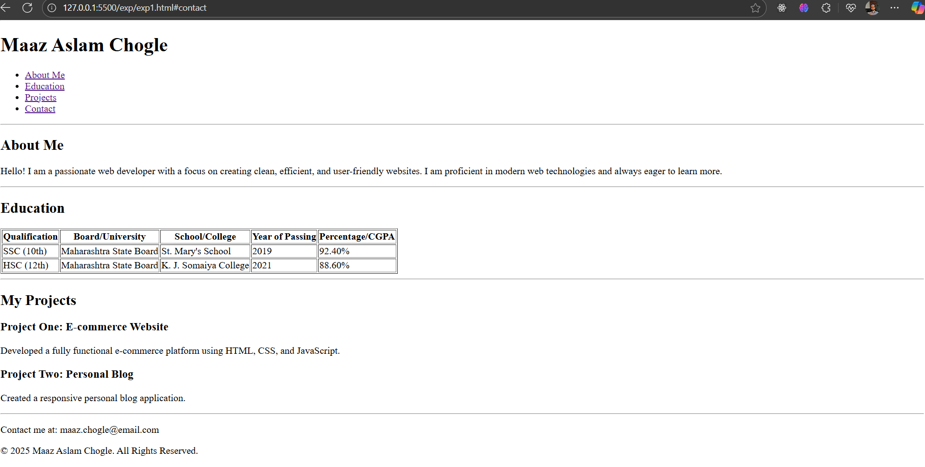

Conclusion:
In this experiment, a personal portfolio webpage was successfully designed and implemented using semantic HTML elements. The use of <header>, <nav>, <section>, <article>, and <footer> provided a meaningful structure to the document, making the code more readable and accessible. This approach is fundamental to modern web development as it improves SEO and maintainability, ensuring that web pages are well-understood by both browsers and developers.

